Lab3:Importing Type Trees using XSD

Objective

Equip you with the knowledge and understanding of the purpose of the XML importers.

- This exercise also introduces use the XML DTD Importer to create type trees that describe the format of XML data.
- This exercise also introduces use the XML XSD Importer to create type trees that describe the format of XML data.
- By completing the exercises you will learn how to create a a typetree by importing a XML XSD and XML DTD:

XML DTD Importer

Use the XML DTD Importer to create type trees that describe the format of XML data.
Many of the type trees that are generated by the Importer Wizard can be immediately used for map development. However, depending on the contents of the interface-specific metadata file, it might be necessary for the generated type tree to be modified using the Type Designer.
You cannot simultaneously have a type tree open in the Type Designer while importing a type tree with the same name.

XML Schema Importer

Use the XML Schema Importer wizard to generate a type tree from an XML Schema.
Supported Schemas
The XML Schema Importer only supports schemas that conform to the 2001 XML Schema specification defined by the Worldwide Web Consortium (W3C). Other schema options, such as BizTalk or XDR, are not supported. However, some providers such as BizTalk provide tools that can convert a proprietary schema to the latest W3C XML Schema specification.

Environment

Windows OS, WTX8.4 Design Studio.

List of components

Employee.mtt,Employee.dtd,Employee.xsd.

Procedure

Step 1:

From the Windows Start menu->Programs-> WebSphere Transformation Extender 8.4 ->Design Studio->Design Studio.



Step2 :

Open the WebSphere Transformation Extender Design Studio and click the OK button to accept the default workspace location or you can browse your own location.
Here location C:\WTXTRAINING\WTX8.4 has been used.
The workspace is the physical directory where your artifacts will be stored.

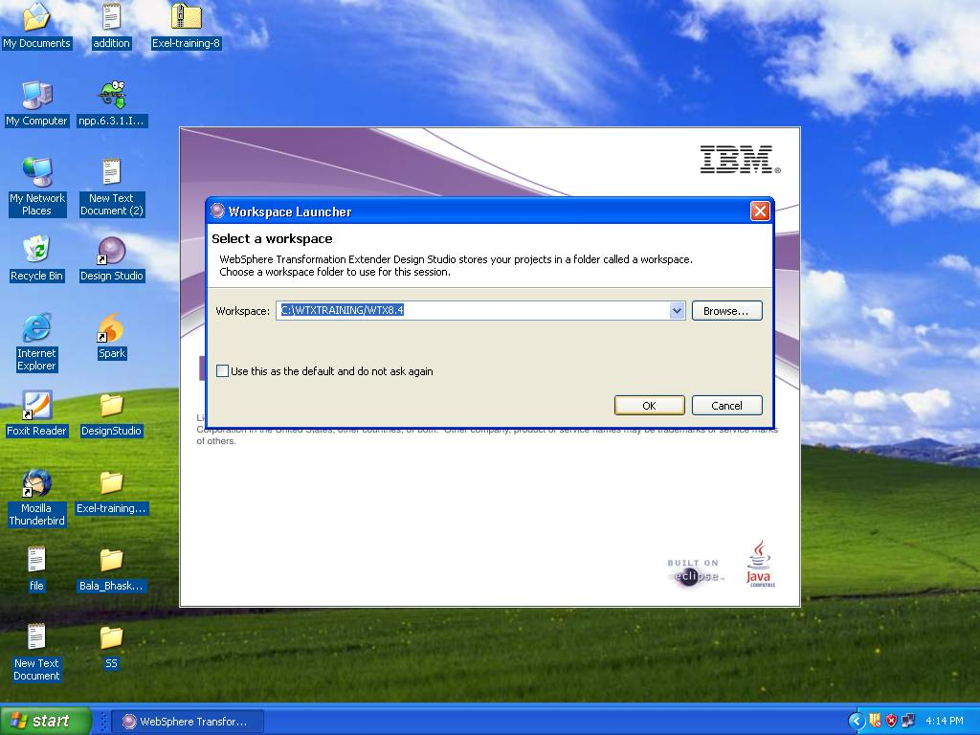

Step 3 :

Go to the File menu and select New->Extender Project to create a new extender project.

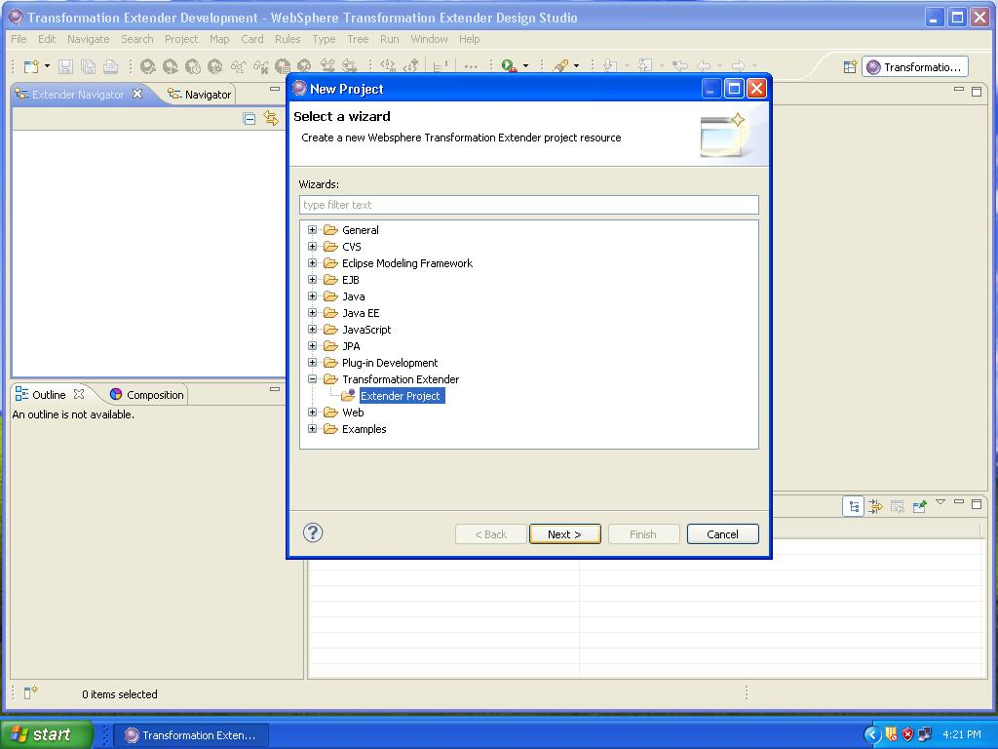

Step 4:

Name this project WTX_Lab3 and accept the default location and click Finish. You have created a subdirectory called WTX_Lab3 in your default workspace. You can use Windows Explorer to view it.

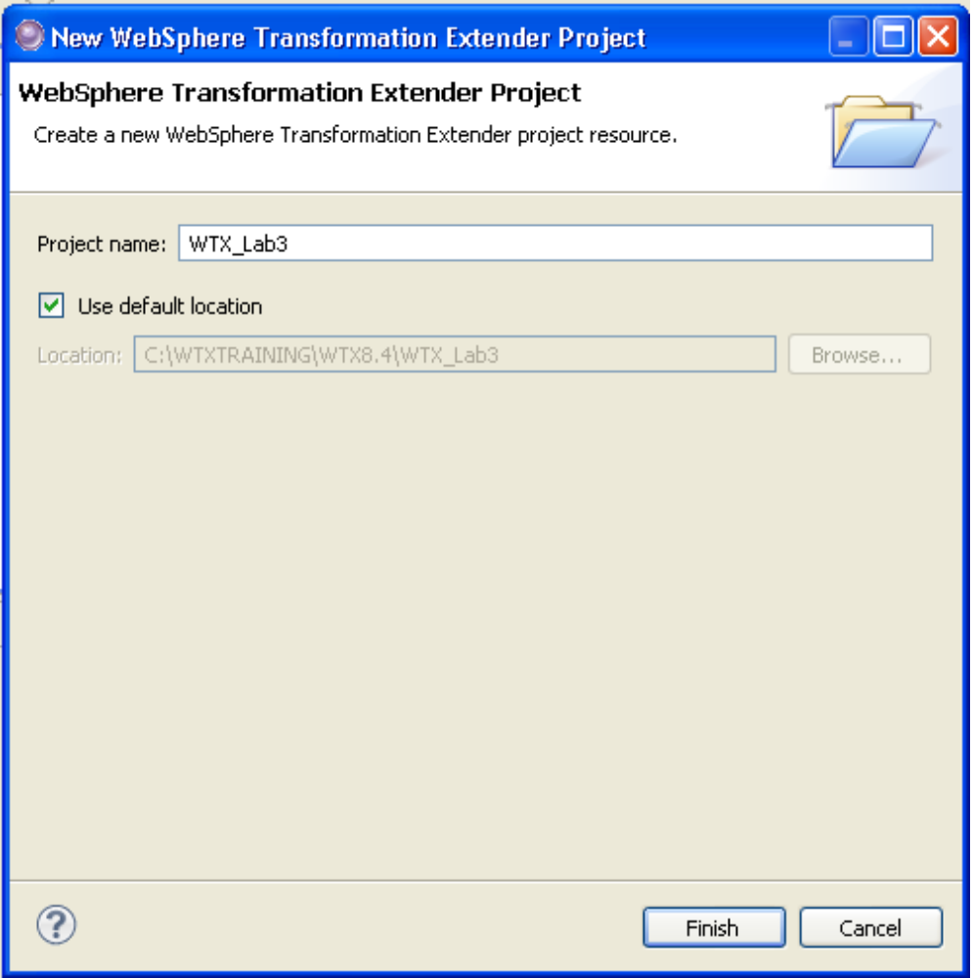

Step 5 :

Import a type tree

We can import a typetree by 2 ways.

1st method

From the menu, choose File→Import.

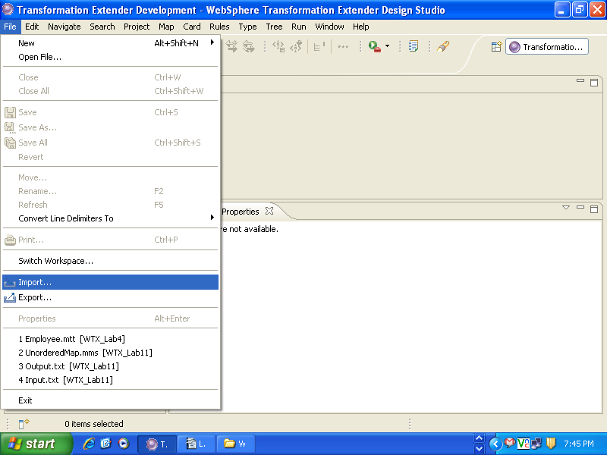

Step 6:

The Importer Wizard – dialog box appears, enabling you to select the XML DTD to import.

Go to Transformation Extender and Select XML DTD from the Importer Wizard dialog box and click Next.

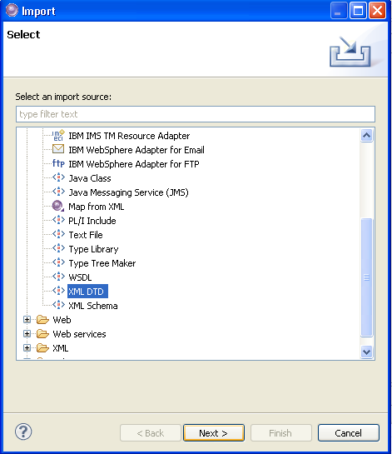

Step 7 :

Import a type tree - Contd.

2nd method

Right-click Type Trees in the WTX_Lab3 project.

Select the Import-> XML DTD which will direct to the screen shown in the step 8.

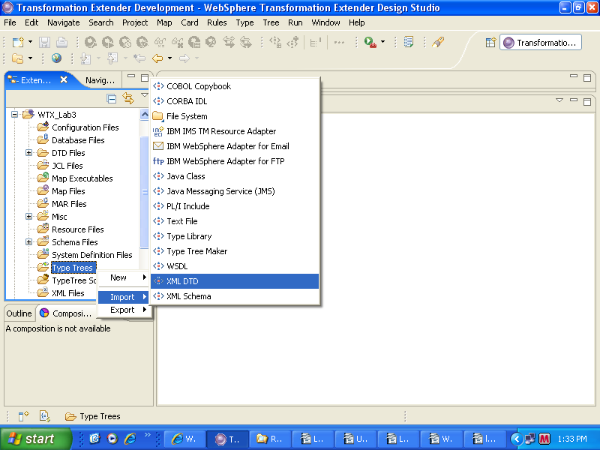

Step 8 :

The XML DTD Importer – dialog box displays a field that allows you to select the URI of a document to import.

Enter the URI of the document that you want to import, or click (browse) to navigate to the the file you want to select.

Here the file location C:\Documents and Settings\miracle\IBM\wtx\workspace is used.

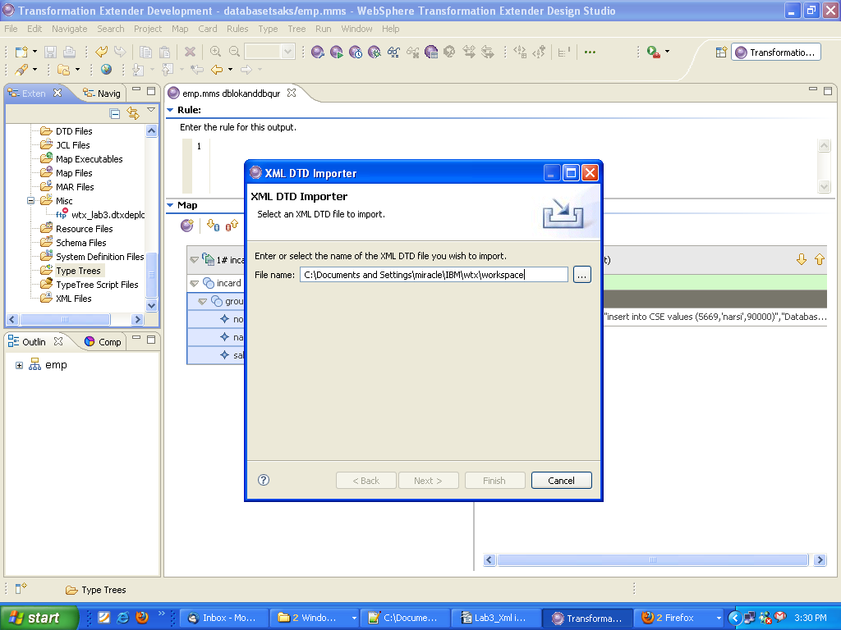

Step 9:

Specify the character and a byte order set that describes the execution-time data (WTX has the ability to work with multiple data languages. Native is the default; it automatically adheres to the format of the specified execution-time platform)

Select the Next tab.

Note : The XML DTD Importer dialog box displays a national language field as Western, Users of this product will have options available and should choose the appropriate national language before proceeding with these instructions.

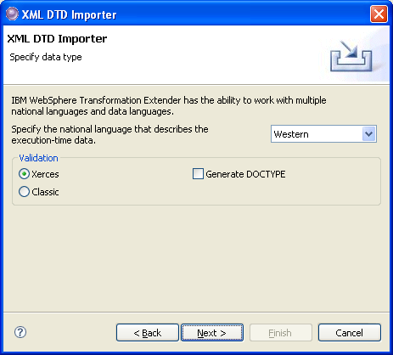

Step 10:

Click WTX_Lab3 to move it to the “Enter or select the parent folder” window. Enter the name of the typetree of the file you wish to create or select a file name. In this example we are giving a name Employee.mtt and select Next.

The destination file will be overwritten if it exists.

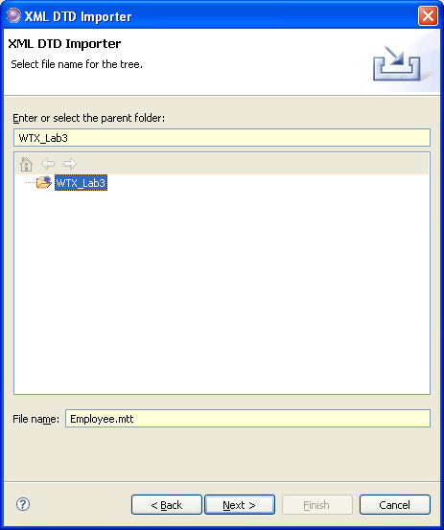

Step 11 :

The Importer Wizard runs the map and a dialog box displays the generated type tree with error or warning counts.
When the type tree is successfully created, click Finish.
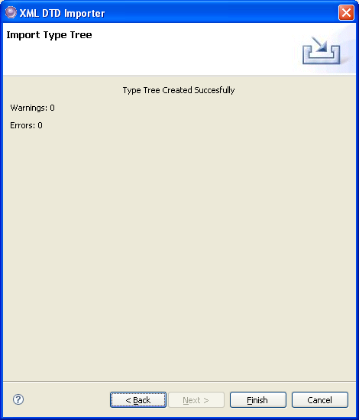

If errors are detected, a message box is displayed giving you the option to view the errors and warnings. If you click Yes, a dialog box appears displaying errors and warnings.

Step 12: View the Type Tree

You will be prompted to open the Type Tree. Click Yes.

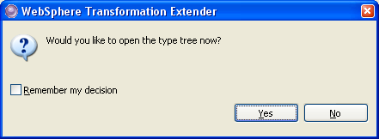
The DTD Importer generates the following type tree from the DTD.
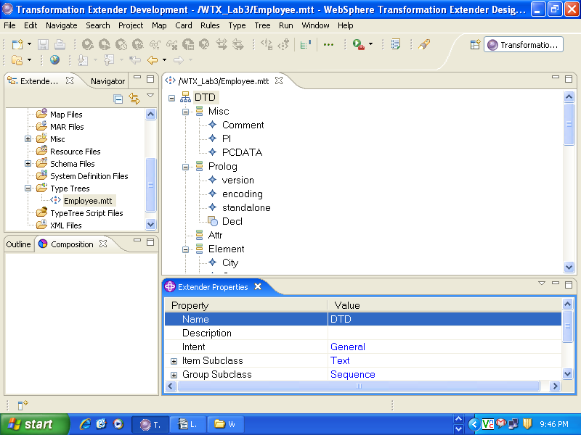

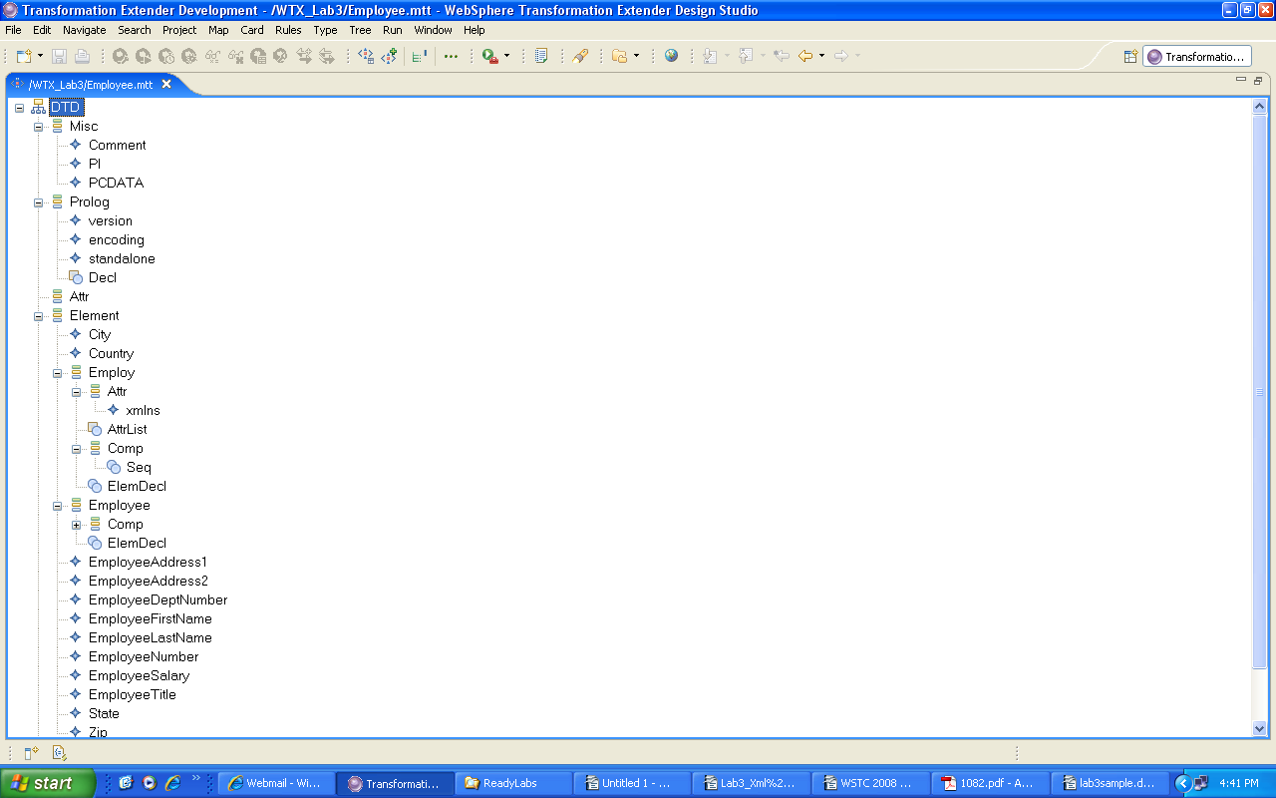

Step13:

We are finished except for analyzing the tree for logical errors and inconsistencies. From the menu, choose Tree Analyze Structure and Logic Only (or use the Analyze logic only icon on the toolbar:

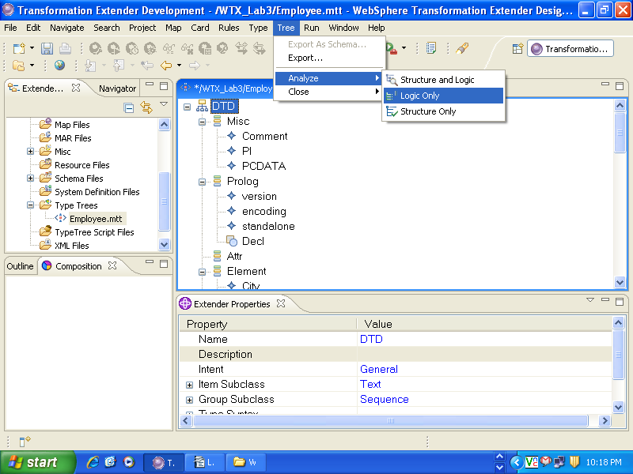

Step14:

Close the Analysis Results window and go the menu, choose File→Save (or use the Save icon from the toolbar) to write the changes to disk.

The tree is now ready to be used in a map.

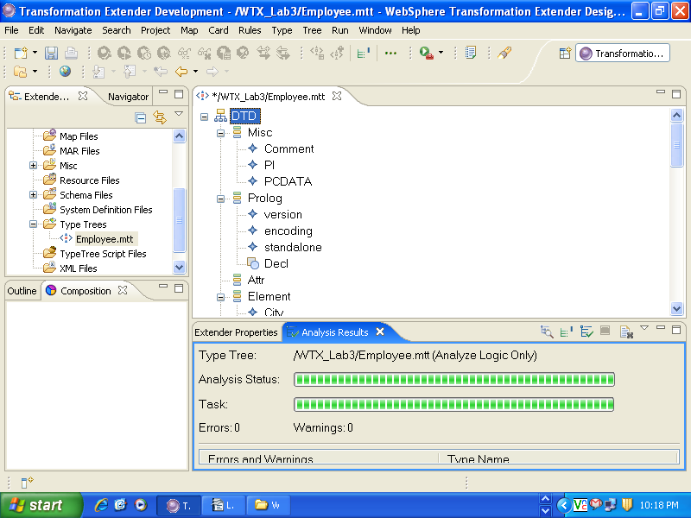

Importing a Typetree (using XSD):

Repeat the steps ( from Step 1 to Step 5 ) of creating a typetree using DTD.

Step 6:

The Importer Wizard – dialog box appears, enabling you to select the XML Schema to import.

Go to Transformation Extender and Select XML Schema from the Importer Wizard dialog box and click Next.

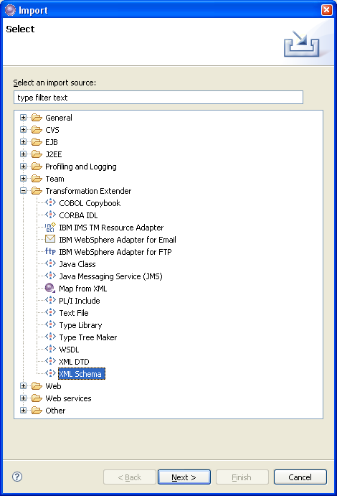

Step 7 :
Import a type tree - Contd.

2nd method

Right-click Type Trees in the WTX_Lab3 project.

Select the Import-> XML Schema which will direct to the screen shown in the step 8.

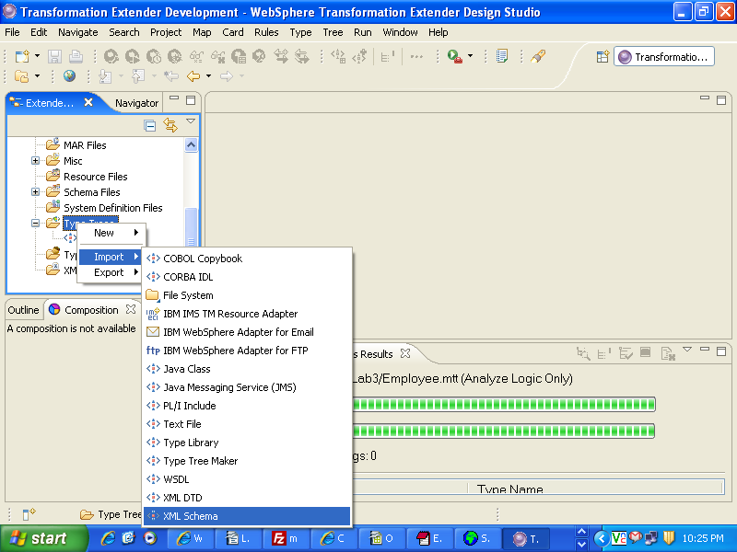

Step 8 :

The XML Schema Importer – dialog box displays a field that allows you to select the URI of a document to import.

Enter the URI of the document that you want to import, or click (browse) to navigate to the the file you want to select.

Here the file location C:\Documents and Settings\miracle\Desktop\stuff\workspace\XML TO FLAT\maps\Employee.xsd you wish to import and click next.

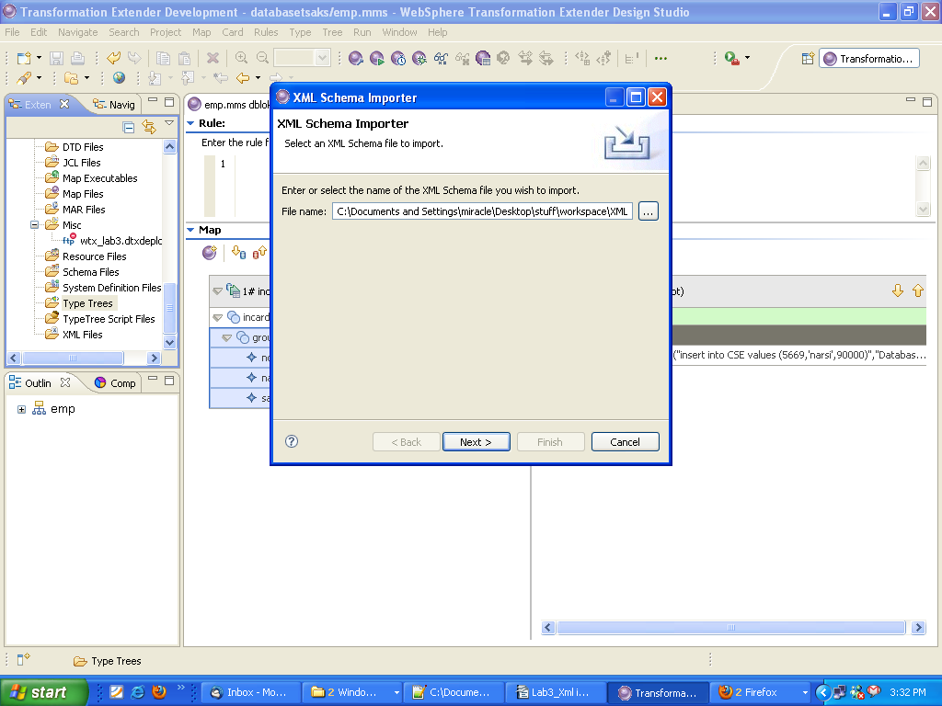

Step 9:

Specify the character and a byte order set that describes the execution-time data (WTX has the ability to work with multiple data languages. Native is the default; it automatically adheres to the format of the specified execution-time platform)

Select the Next tab.

Note : The XML Schema Importer dialog box displays a national language field as Western, Users of this product will have options available and should choose the appropriate national language before proceeding with these instructions.

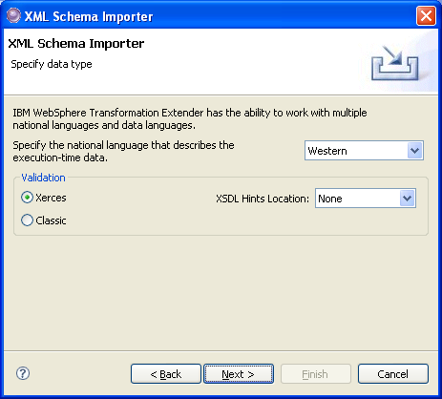

Step 10:

Click WTX_Lab3 to move it to the “Enter or select the parent folder” window. Enter the name of the typetree of the file you wish to create or select a file name. In this example we are giving a name Employee.mtt and select Next.

The destination file will be overwritten if it exists.

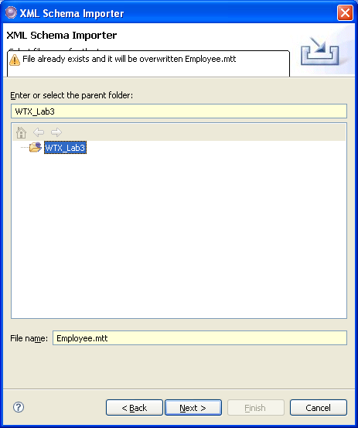

Step 11 :

The Importer Wizard runs the map and a dialog box displays the generated type tree with error or warning counts.
When the type tree is successfully created, click Finish.

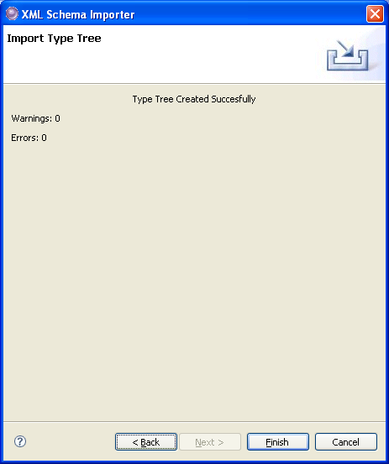

If errors are detected, a message box is displayed giving you the option to view the errors and warnings. If you click Yes, a dialog box appears displaying errors and warnings.

Step 12: View the Type Tree

You will be prompted to open the Type Tree. Click Yes.

The XML Schema Importer generates the following type tree from the schema

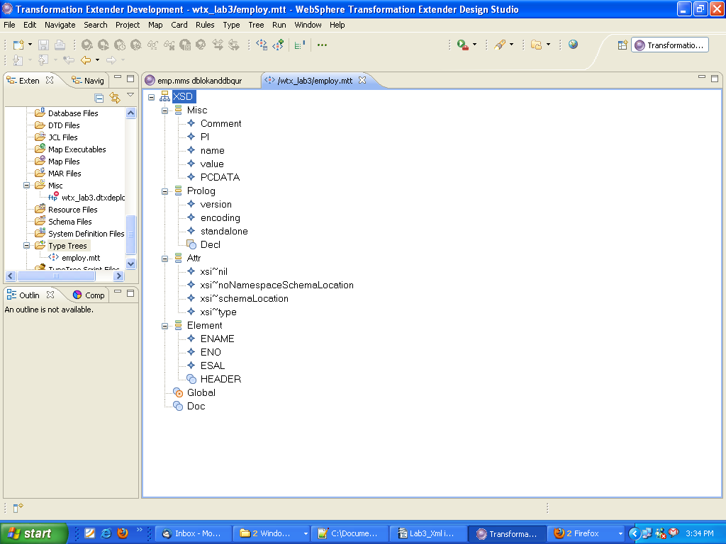

Step 13:

We are finished except for analyzing the tree for logical errors and inconsistencies. From the menu, choose Tree Analyze Structure and Logic or use the Analyze logic only icon on the toolbar:

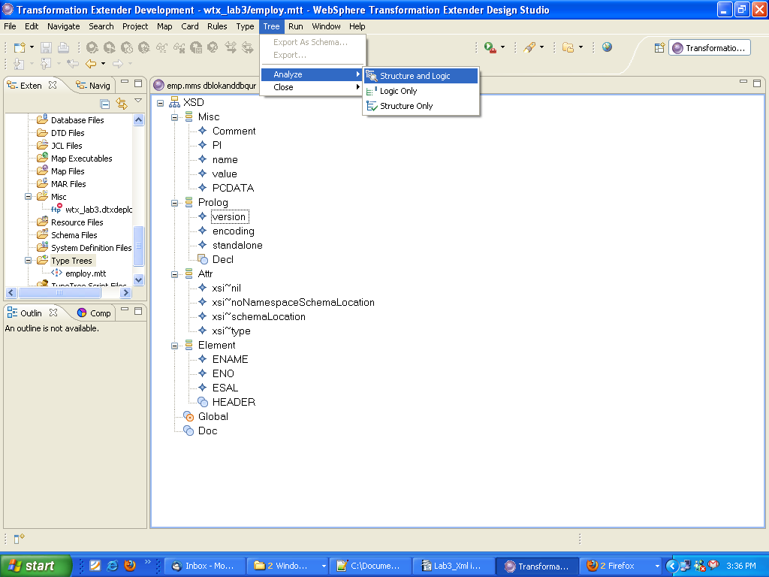

Step 14:

Close the Analysis Results window and go the menu, choose File→Save (or use the Save icon from the toolbar) to write the changes to disk.

The tree is now ready to be used in a map.

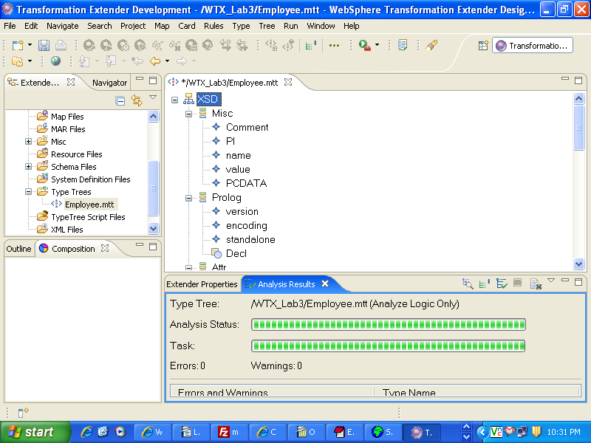

Limitation & Constraints:

1. The xsi:type attribute is not supported. If this attribute is present in an XML Schema and the type properties set by the importer are not valid, you can manually modify the type tree in the Type Designer after it is generated.

2. There is a limitation regarding the "union" XML Schema datatype. During the import process, the union datatype is converted to a text item in the type tree. As a result, you cannot create rules for mapping the member subtypes.

